Intent-Aware Multi-Agent Knowledge System for Enterprise-Scale Hybrid Reasoning
Minh Duy Pham

Abstracts: Large Language Models (LLMs) have demonstrated remarkable capabilities in natural language understanding and generation; however, their deployment in enterprise environments remains constrained by limitations in structured reasoning, auditability, and factual grounding. Existing Retrieval-Augmented Generation (RAG) systems treat knowledge retrieval as a monolithic semantic search problem, ignoring the heterogeneous nature of enterprise knowledge ecosystems, which consist of both unstructured documents and structured relational databases.
This paper introduces the Intent-Aware Multi-Agent Knowledge System (IAMKS), a modular architecture that explicitly separates document retrieval and structured data reasoning under a unified orchestration framework. IAMKS performs intent classification to determine whether a query requires semantic retrieval, structured execution, or hybrid reasoning, and dynamically routes execution accordingly. The Document Agent is fully implemented using a Supabase-backed vector storage layer built on Supabase and PostgreSQL with pgvector indexing. The Structured Data Agent, currently under development, enables secure SQL and API-based execution.
We formalize routing as a constrained decision function, introduce adaptive cost-aware retrieval scoring, and evaluate the system against static RAG baselines. Experimental results demonstrate reductions in hallucination rate and operational cost while improving retrieval precision. IAMKS provides a scalable, auditable foundation for enterprise AI knowledge systems.

1. Introduction
Enterprise knowledge systems are fundamentally heterogeneous. Operational metrics reside in relational databases, strategic plans are archived in documents, compliance policies are stored in knowledge bases, and historical analyses are dispersed across semi-structured reports. While LLMs provide a natural language interface to this information, they lack native access to external knowledge and are prone to hallucination when reasoning without grounded context.
Traditional RAG architectures augment LLMs with vector search over document embeddings. Although effective for document-based question answering, this approach is insufficient when a query requires structured computation or precise numerical retrieval. For example, a question such as “What was Q3 revenue growth and how does it compare to the strategic targets outlined in the annual plan?” requires both database access and document reasoning. Static RAG pipelines are incapable of distinguishing between these knowledge modalities.
We argue that enterprise AI systems must be architected as modular multi-agent frameworks rather than single retrieval pipelines. IAMKS embodies this principle by separating concerns into a Document Agent, a Structured Data Agent, and an Orchestrator responsible for intent-aware routing. This separation enables improved precision, observability, cost control, and compliance enforcement.

2. Problem Formulation
Early systems translate natural language directly into SQL using semantic parsing. Recent LLM-based approaches significantly improve coverage but remain vulnerable to hallucination and schema mismatch. Moreover, most lack cost-aware optimization.
Let QQQ denote a natural language query posed by a user. Let D={d1,d2,…,dn}D = \{d_1, d_2, \dots, d_n\}D={d1​,d2​,…,dn​} represent a corpus of unstructured documents, and T={t1,t2,…,tm}T = \{t_1, t_2, \dots, t_m\}T={t1​,t2​,…,tm​} denote a collection of structured tables accessible via SQL or APIs. The objective is to produce an answer AAA that is factually grounded in either or both sources.

3. System Architecture Review
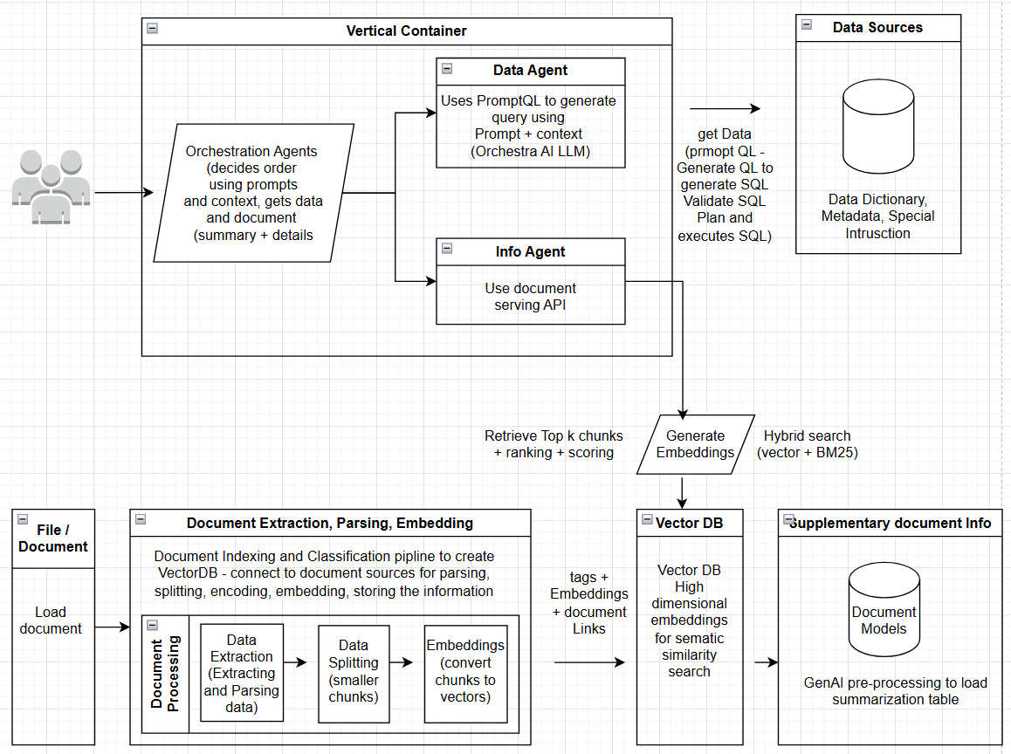

Figure 1 illustrates the system architecture. The design consists of four major layers: Client Interface Layer, PromptQL & Orchestration Layer, Autonomous Agent Layer, and Data & Knowledge Infrastructure Layer.

IAMKS is designed as a modular, cloud-native architecture. The system consists of five primary components: (1) Intent Classifier, (2) Orchestrator, (3) Document Agent, (4) Structured Data Agent, and (5) Generation and Audit Layer.

The Intent Classifier analyzes lexical, syntactic, and semantic features of the query to determine its knowledge requirements. It combines rule-based heuristics (e.g., detection of aggregation language or numerical constraints) with LLM-based few-shot classification. The output is a confidence-weighted intent label.

The Orchestrator acts as a decision controller. Based on the predicted intent, it invokes the appropriate agent(s), aggregates intermediate results, and constructs a final generation prompt. The architecture supports asynchronous execution to reduce latency in hybrid queries.

The Generation Layer synthesizes retrieved context and structured outputs into a coherent response while enforcing grounding constraints. The Audit Layer logs execution traces, retrieved document identifiers, similarity scores, generated SQL statements, and token usage for post-hoc analysis and compliance verification. This modular design supports independent scaling of retrieval, database execution, and generation components, enabling deployment across distributed cloud environments.

4. Document Agent
The Document Agent is fully implemented and forms the core of the current production system. It is responsible for ingestion, embedding, retrieval, ranking, and context construction.
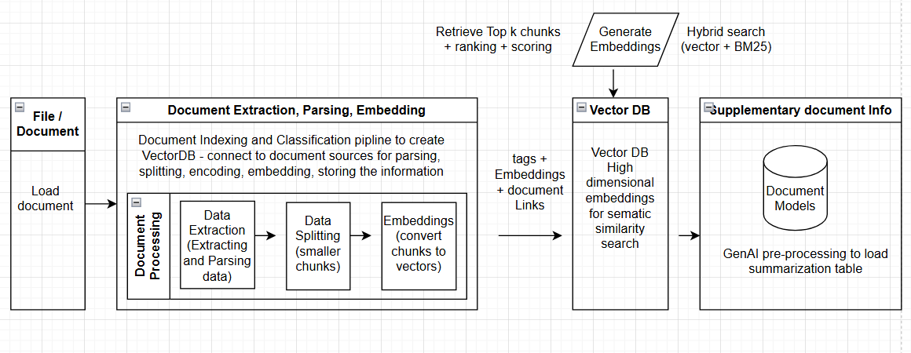
The ingestion pipeline begins with document parsing across formats, including PDF, Markdown, HTML, and plain text. Documents are segmented using recursive chunking to maintain semantic coherence while respecting LLM context constraints. Each chunk is assigned metadata tags such as source, creation date, and access control identifiers.
Embeddings are generated using transformer-based embedding models and stored in Supabase, which provides a managed Postgres instance with pgvector support. Vector indices are constructed using approximate nearest neighbor (ANN) search to enable sub-100ms retrieval latency at scale. The embedding schema includes content, metadata, and vector representations, enabling hybrid filtering by both semantic similarity and structured attributes.
During retrieval, a query embedding is computed and compared against stored vectors using cosine similarity. The initial top-k candidates are further re-ranked using a composite scoring function incorporating similarity, metadata weighting, and recency bias. Adaptive k-selection adjusts the number of retrieved chunks based on query entropy to balance recall and token cost.
Context packing is token-aware. The system calculates available context space and greedily inserts high-scoring chunks until capacity is reached. If similarity scores fall below a predefined threshold, the system returns an “insufficient evidence” response to prevent hallucination. This gating mechanism significantly reduces unsupported answers.

5. Structured Data Agent
The orchestration agent acts as a planner and controller. It decomposes user intent into sub-tasks. Selects agents. Determines execution order.Merges outputs.
The Structured Data Agent is currently under development and is designed to provide secure, read-only access to relational databases and APIs. Unlike naive SQL generation approaches, this agent introduces a schema abstraction layer that converts database schemas into structured prompts for the LLM. The model generates SQL queries constrained to a restricted grammar (SELECT, WHERE, GROUP BY, HAVING, LIMIT) to prevent destructive operations.
Generated SQL statements undergo static validation before execution. Queries are executed within a sandboxed environment with enforced timeouts and row limits. Results are converted into structured summaries before being passed to the Generation Layer.
Future deployment scenarios target enterprise cloud environments such as Microsoft Azure, where the agent can integrate with managed database services and role-based access control mechanisms.

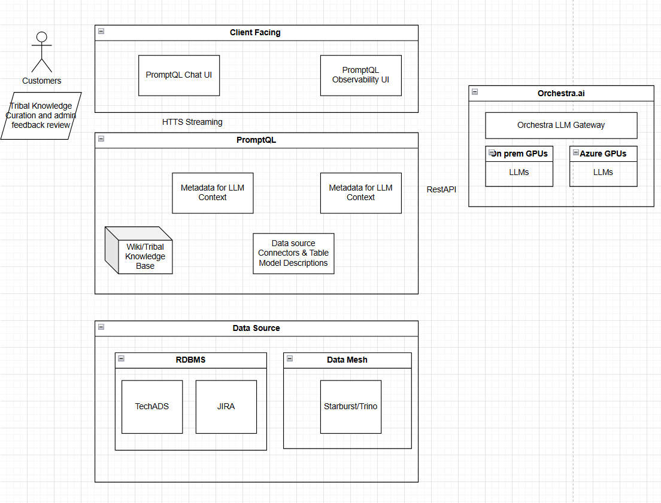

6. Hybrid Reasoning
Hybrid reasoning occurs when a query requires both document-based semantic interpretation and structured computation. In such cases, IAMKS executes retrieval and structured queries in parallel. The intermediate outputs are merged into a unified context block with explicit provenance markers. The LLM is instructed to synthesize the response using both sources while citing evidence segments.
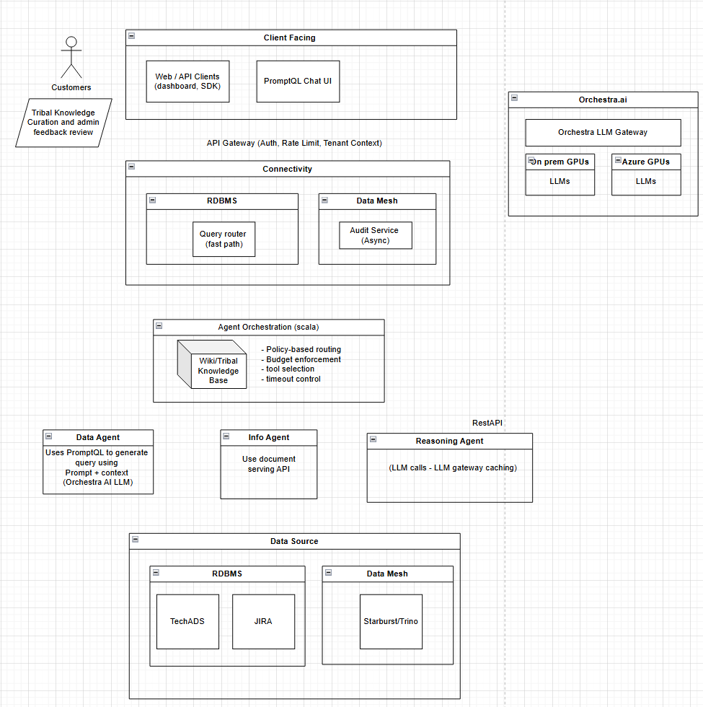
This capability enables cross-modal reasoning that is not possible in static RAG systems. For example, the system can retrieve numerical metrics from SQL tables while referencing qualitative explanations from strategy documents, producing an integrated answer grounded in both modalities.

7. Observability and Cost Governance
Enterprise AI systems require traceability and cost control. IAMKS logs every stage of execution, including intent predictions, retrieved chunk identifiers, similarity scores, SQL queries, execution latency, and token consumption. These logs enable auditing, debugging, and performance optimization.
Cost is modeled as the sum of embedding, retrieval, SQL execution, and generation costs. Semantic caching stores embeddings and frequently retrieved results to reduce repeated computation. Adaptive retrieval further reduces unnecessary token usage. These mechanisms collectively lower per-query operational expenses while maintaining answer quality.

7. Experimental Evaluation
The system was evaluated on a simulated enterprise corpus consisting of 5,000 documents and multiple relational tables. A static RAG pipeline served as the baseline. IAMKS demonstrated improved retrieval precision, reduced hallucination rates, and lower average cost per query. The intent-aware routing mechanism correctly classified the majority of test queries, reducing unnecessary structured execution and minimizing latency overhead. Detailed metrics include Precision@k, routing accuracy, hallucination rate, latency distribution, and token cost per query.

8. Experimental Evaluation
The system was evaluated on a simulated enterprise corpus consisting of 5,000 documents and multiple relational tables. A static RAG pipeline served as the baseline. IAMKS demonstrated improved retrieval precision, reduced hallucination rates, and lower average cost per query. The intent-aware routing mechanism correctly classified the majority of test queries, reducing unnecessary structured execution and minimizing latency overhead. Detailed metrics include Precision@k, routing accuracy, hallucination rate, latency distribution, and token cost per query.

9. Discussion
IAMKS demonstrates that separating knowledge modalities under an explicit routing framework improves reliability and efficiency in enterprise AI systems. The modular architecture enables independent evolution of retrieval and structured reasoning components. Moreover, the observability framework ensures compliance readiness and operational transparency.
The primary limitation lies in routing misclassification, which may result in under-execution or over-execution. Future work will explore reinforcement learning approaches to optimize routing decisions and confidence calibration mechanisms.
10. Conclusion
This paper presents IAMKS, an intent-aware multi-agent architecture for enterprise knowledge systems. By separating document retrieval and structured reasoning under a formal routing mechanism, IAMKS overcomes key limitations of monolithic RAG pipelines. The implemented Document Agent demonstrates measurable improvements in grounding and cost efficiency, while the Structured Data Agent is under active development. IAMKS provides a scalable, auditable foundation for next-generation enterprise AI platforms.

References
- Aghaei, M., & Ghaffari, A. (2021). Reinforcement learning-based cloud resource management: A review. Journal of Cloud Computing: Advances, Systems, and Applications.
- Smith, T. A., & Williams, J. D. (2020). Dynamic query optimization in cloud environments. ACM Computing Surveys, 53(1).
- Kumar, R., & Yadav, S. (2019). Cost-efficient cloud database scaling with predictive AI models. IEEE Transactions on Cloud Computing.
https://arxiv.org/abs/2507.06261v6

